Point–Line Collinearity
# Source: AI Source: Provided by: [Data Path: Persons Table -> ID Column: 1, Name_En Column: Motasem Essam] -> From: [ChatGPT] on [7/25/2026]
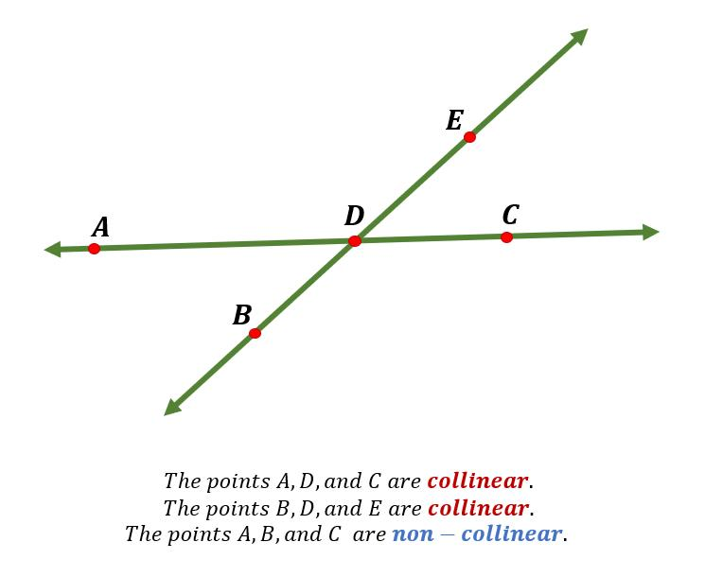
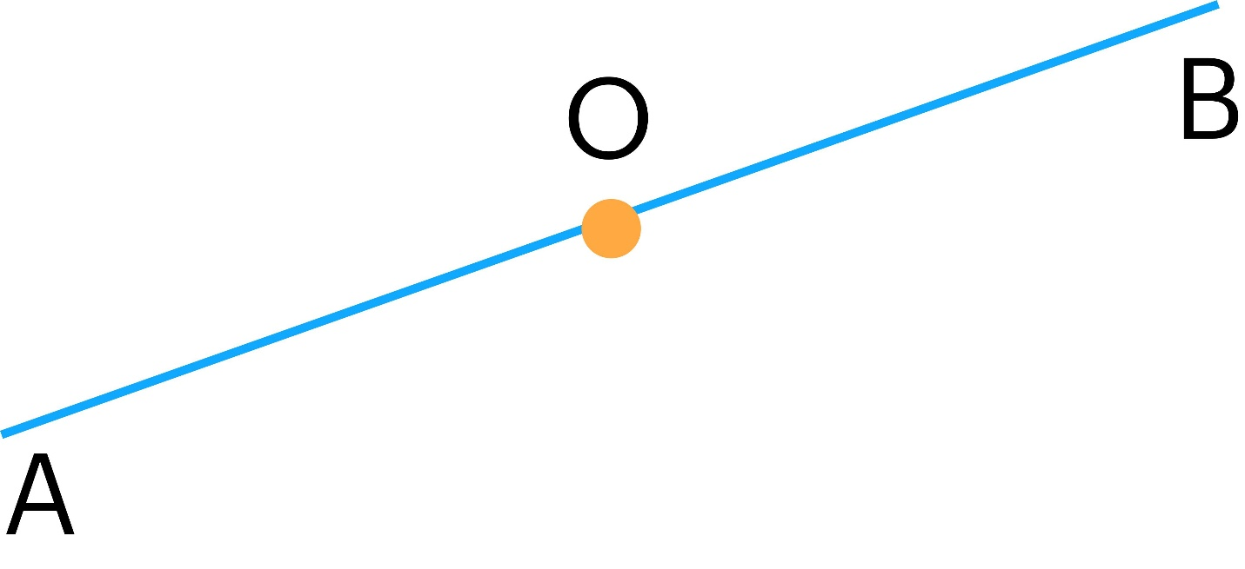
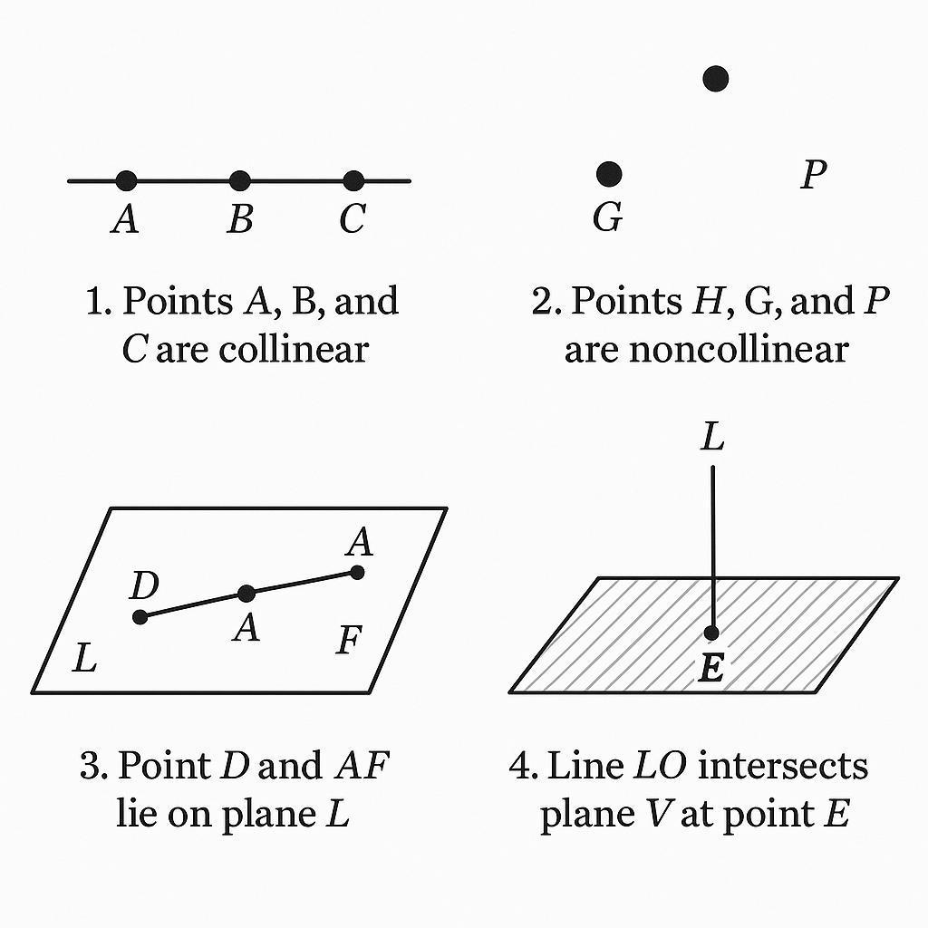
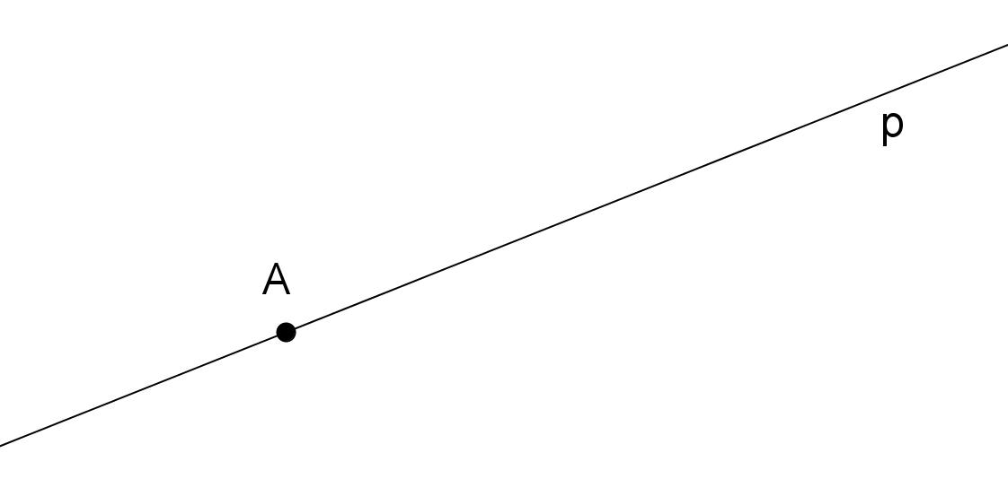

Definition
# Source: AI Source: Provided by: [Data Path: Persons Table -> ID Column: 1, Name_En Column: Motasem Essam] -> From: [ChatGPT] on [7/25/2026]
Point–Line Collinearity is a geometric relationship in which a point and a line are aligned on the same straight geometric line.
For a point $P$and a line $l$, point–line collinearity means simply that:
$$\boxed{P∈l}$$
In other words, the point lies on the line.
Basic Representation
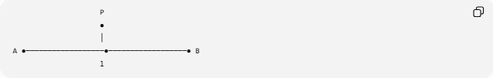
P
●
│
A ●──────────────────●──────────────────● B
l
More simply:
A ●──────────────● P──────────────● B
l
Here:
$$P∈l$$
and therefore $P$is collinear with every point on $l$.

Fundamental Concept
# Source: AI Source: Provided by: [Data Path: Persons Table -> ID Column: 1, Name_En Column: Motasem Essam] -> From: [ChatGPT] on [7/25/2026]
A line extends infinitely in both directions.
◀────────────────────────────────────────▶
l
Unlike a segment or ray, a line has:
- No endpoints
- Infinite extent in both directions
- A single straight direction
Therefore, if a point lies on the line, there is no additional between-ness or direction condition.
This makes point–line collinearity simpler than point–segment or point–ray relationships.

Point on a Line
# Source: AI Source: Provided by: [Data Path: Persons Table -> ID Column: 1, Name_En Column: Motasem Essam] -> From: [ChatGPT] on [7/25/2026]
If:
$$P∈l$$
then $P$is on line $l$.
For example:
l: ●────────●────────●────────●────────●
A P B
Since $P$lies on $l$:
$$P∈l$$
This is simultaneously:
- Point–Line Collinearity
- Point–Line Incidence
If the emphasis is that $P$belongs to the line, incidence is the more fundamental relation.
If the emphasis is that $P$is aligned with the line as a straight-line object, it can be classified under Line-Object Collinearity.

Mathematical Representation
# Source: AI Source: Provided by: [Data Path: Persons Table -> ID Column: 1, Name_En Column: Motasem Essam] -> From: [ChatGPT] on [7/25/2026]
A line in the Cartesian plane can be written as:
$$ax+by+c=0$$
where $a$and $b$are not both zero.
For a point:
$$P=\left(x_{0} , y_{0}\right)$$
the point lies on the line exactly when:
$$\boxed{ax_{0}+by_{0}+c=0}$$
This is the standard algebraic test for point–line incidence.

Example 1: Horizontal Line
# Source: AI Source: Provided by: [Data Path: Persons Table -> ID Column: 1, Name_En Column: Motasem Essam] -> From: [ChatGPT] on [7/25/2026]
Consider:
$$l:y=4$$
and:
$$P=\left(7 , 4\right)$$
Substituting the coordinates:
$$y=4$$
Therefore:
$$P∈l$$
So $P$is point–line collinear with $l$.

Example 2: Vertical Line
# Source: AI Source: Provided by: [Data Path: Persons Table -> ID Column: 1, Name_En Column: Motasem Essam] -> From: [ChatGPT] on [7/25/2026]
Consider:
$$l:x=5$$
and:
$$P=\left(5 , 9\right)$$
Since the $x$-coordinate of $P$is $5$:
$$P∈l$$
Therefore:
$$\boxed{P\text{ lies on }l}$$

Example 3: Oblique Line
# Source: AI Source: Provided by: [Data Path: Persons Table -> ID Column: 1, Name_En Column: Motasem Essam] -> From: [ChatGPT] on [7/25/2026]
Consider:
$$l:y=2x+1$$
and:
$$P=\left(3 , 7\right)$$
Substitute $x=3$:
$$y=2\left(3\right)+1 \\ y=7$$
Therefore:
$$P=\left(3 , 7\right)∈l$$
So $P$lies on the line.

Parametric Representation
# Source: AI Source: Provided by: [Data Path: Persons Table -> ID Column: 1, Name_En Column: Motasem Essam] -> From: [ChatGPT] on [7/25/2026]
A line can also be represented parametrically:
$$r\left(t\right)=A+tv$$
where:
- $A$is a point on the line.
- $v$is a nonzero direction vector.
- $t∈R$.
A point $P$lies on the line if:
$$\boxed{P=A+tv}$$
for some:
$$t∈R$$
The important feature is:
$$\boxed{t∈R}$$
There is no restriction such as $t≥0$or $0≤t≤1$.

Comparison with Segment and Ray
# Source: AI Source: Provided by: [Data Path: Persons Table -> ID Column: 1, Name_En Column: Motasem Essam] -> From: [ChatGPT] on [7/25/2026]
The parameter $t$provides a useful unified distinction.
Line
$$\boxed{t∈R}$$
◀──────────────A──────────────▶
negative positive
Ray
For $\vec{AB}$:
$$\boxed{t≥0}$$
A──────────────────────────────▶
Segment
For $\overset{‾}{AB}$:
$$\boxed{0≤t≤1}$$
A──────────────────────────────B
Therefore:
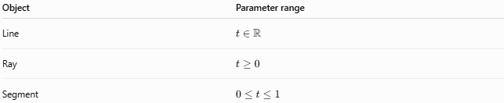
Object | Parameter range
Line | $$t∈R$$
Ray | $$t≥0$$
Segment | $$0≤t≤1$$
This is why point–line collinearity has no endpoint or direction restriction.

Point–Line Incidence
# Source: AI Source: Provided by: [Data Path: Persons Table -> ID Column: 1, Name_En Column: Motasem Essam] -> From: [ChatGPT] on [7/25/2026]
Point–line collinearity is very closely related to incidence.
If:
$$P∈l$$
then $P$is incident with $l$.
The distinction is mainly one of emphasis:
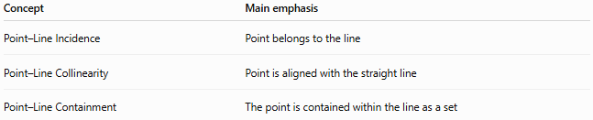
Concept | Main emphasis
Point–Line Incidence | Point belongs to the line
Point–Line Collinearity | Point is aligned with the straight line
Point–Line Containment | The point is contained within the line as a set
For ordinary Euclidean geometry, the statement
$$P∈l$$
is most naturally described as point–line incidence.

Relationship to Three-Point Collinearity
# Source: AI Source: Provided by: [Data Path: Persons Table -> ID Column: 1, Name_En Column: Motasem Essam] -> From: [ChatGPT] on [7/25/2026]
Suppose:
$$A,B,P∈l$$
Then:
$$A, B, P$$
are three collinear points.
Thus:
$$\boxed{P∈l⇒A,B,P\text{ are collinear}}$$
provided $A$and $B$are points on $l$.
Conversely, if $A≠B$and $A,B,P$are collinear, then $P$lies on the unique line determined by $A$and $B$:
$$\boxed{P∈\overset{↔}{AB}}$$

Unique Line Through Two Points
# Source: AI Source: Provided by: [Data Path: Persons Table -> ID Column: 1, Name_En Column: Motasem Essam] -> From: [ChatGPT] on [7/25/2026]
If:
$$A≠B$$
then exactly one line passes through $A$and $B$:
$$\boxed{\overset{↔}{AB}}$$
If $P$is also collinear with $A$and $B$:
$$P∈\overset{↔}{AB}$$
Therefore, three-point collinearity can be expressed as point–line incidence:
A ●────────P ●────────B
overleftrightarrow{AB}

Special Cases

1. Point at a Chosen Reference Point
# Source: AI Source: Provided by: [Data Path: Persons Table -> ID Column: 1, Name_En Column: Motasem Essam] -> From: [ChatGPT] on [7/25/2026]
Any point on the line can serve as a reference point.
$$P∈l$$
There is no concept of an endpoint because a line has no endpoints.

2. Point Between Two Other Points
# Source: AI Source: Provided by: [Data Path: Persons Table -> ID Column: 1, Name_En Column: Motasem Essam] -> From: [ChatGPT] on [7/25/2026]
A ●────────P ●────────B
Then:
$$P∈l$$
and:
$$AP+PB=AB$$
But the between-ness is not required for point–line collinearity.

3. Point Outside the Segment Determined by Two Points
# Source: AI Source: Provided by: [Data Path: Persons Table -> ID Column: 1, Name_En Column: Motasem Essam] -> From: [ChatGPT] on [7/25/2026]
P ●──────A ●────────B
The point is still on the same line:
$$P∈\overset{↔}{AB}$$
Thus $P,A,B$remain collinear.

Collinearity Test Using Three Points
# Source: AI Source: Provided by: [Data Path: Persons Table -> ID Column: 1, Name_En Column: Motasem Essam] -> From: [ChatGPT] on [7/25/2026]
If the line is not explicitly given and we have:
$$A=\left(x_{1} , y_{1}\right) \\ B=\left(x_{2} , y_{2}\right) \\ P=\left(x_{3} , y_{3}\right)$$
then $P$lies on the line through $A$and $B$when:
$$\boxed{\left(x_{2}-x_{1}\right)\left(y_{3}-y_{1}\right)-\left(y_{2}-y_{1}\right)\left(x_{3}-x_{1}\right)=0}$$
This condition means that $A$, $B$, and $P$are collinear.

Important Properties
# Source: AI Source: Provided by: [Data Path: Persons Table -> ID Column: 1, Name_En Column: Motasem Essam] -> From: [ChatGPT] on [7/25/2026]
- A line has infinite extent in both directions.
- A point on a line satisfies:
$$P∈l$$
- There is no endpoint restriction.
- There is no directional restriction.
- Every point on a line is collinear with the line.
- Point–line collinearity is equivalent to point–line incidence when the line is explicitly given.
- If $A≠B$, exactly one line passes through $A$and $B$.
- Any point on that line is collinear with $A$and $B$.
- A point can lie between two other points on the line or outside the segment determined by them.
- Point–line collinearity is the simplest point-to-linear-object relationship among segment, ray, and line.

Comparison with Point–Segment and Point–Ray Collinearity
# Source: AI Source: Provided by: [Data Path: Persons Table -> ID Column: 1, Name_En Column: Motasem Essam] -> From: [ChatGPT] on [7/25/2026]
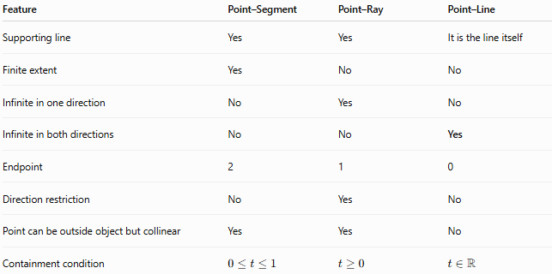
Feature | Point–Segment | Point–Ray | Point–Line
Supporting line | Yes | Yes | It is the line itself
Finite extent | Yes | No | No
Infinite in one direction | No | Yes | No
Infinite in both directions | No | No | Yes
Endpoint | 2 | 1 | 0
Direction restriction | No | Yes | No
Point can be outside object but collinear | Yes | Yes | No
Containment condition | $$0≤t≤1$$ | $$t≥0$$ | $$t∈R$$
The crucial distinction is:
$$\boxed{\text{Segment: }0≤t≤1 \text{Ray: }t≥0 \text{Line: }t∈R}$$

Key Points
# Source: AI Source: Provided by: [Data Path: Persons Table -> ID Column: 1, Name_En Column: Motasem Essam] -> From: [ChatGPT] on [7/25/2026]
- Point–Line Collinearity describes the alignment of a point with a straight line.
- The fundamental condition is:
$$\boxed{P∈l}$$
- A line extends infinitely in both directions.
- There are no endpoint or directional restrictions.
- If $A≠B$, a point $P$is collinear with $A,B$exactly when:
$$P∈\overset{↔}{AB}$$
- In standard geometry terminology, $P∈l$is primarily a statement of point–line incidence; it is placed under Line-Object Collinearity when the taxonomy emphasizes common straight-line alignment.

Conclusion
# Source: AI Source: Provided by: [Data Path: Persons Table -> ID Column: 1, Name_En Column: Motasem Essam] -> From: [ChatGPT] on [7/25/2026]
Point–Line Collinearity is the relationship in which a point lies on a straight line. Unlike a segment or ray, the line has no endpoints and extends infinitely in both directions, so there are no additional between-ness or directional conditions. Mathematically, the relationship is simply represented by:
$$\boxed{P∈l}$$
This makes it the most direct form of Line-Object Collinearity.

